Sunshine Coast School Sport

Professional development procedure and claim guide

Before registering or attending a professional learning event:
- You must complete the ATTENDING approval template electronically.
- Complete the Word template (below), copy the table and paste it into a blank email.
- Send the email to the sport office to be processed.
- The sport office RSSO approves and records that you will be attending the professional learning event.
- Approval is emailed back to your from the sports office.
- Only register to attend a professional learning event when you receive approval to do so from the sports office.
- If travel is required to attend the professional learning event, you need to follow the North Coast Region travel approval process.
=============================================================================
Attending an event/meeting
This application is to be used to gain prior approval for expenses associated with attendance at a professional development activity as a participant. All professional development applications must be approved by a financial delegate. Once approved, application will be saved in HPE Records Manager and the HPE Reference Number emailed to the applicant.

This form is not required when staff are invited to attend an activity to present an information session or where they attend in an official capacity as a departmental representative. In these cases, diarised line manager approval is sufficient. However, evidence of line manager approval will be required to support the payment of any expenses associated with attendance at these types of activities (e.g. approved travel diary, approved email request etc.).
Applicant Details
Name: |  | Contact phone number:
Activity Details
Name of Professional Development - or - Training Activity:
Date:
Venue / Location:

Anticipated Expenditure (including GST)
Course Registration Fee | $ 0 | Meals & Incidental Allowance | $
Travel Costs (incl. fares) (NCR travel approval process will need to be followed) | $ 0 | Accommodation  (NCR travel approval process will need to be followed) | $
Other Costs | $0 | Total Anticipated Expenditure | $ 0

Please see the attached program details (i.e. flyer, information)

=============================================================================

Making an expense claim in expenseme PRO
DoE staff only

STEP 1
Go to OnePortal and search for “Expenseme pro”. Alternatively, you may follow this hyperlink below if you are logged into the department’s network.
https://secure.inlogik.com/doecorp/pm/trans/fast_track.asp
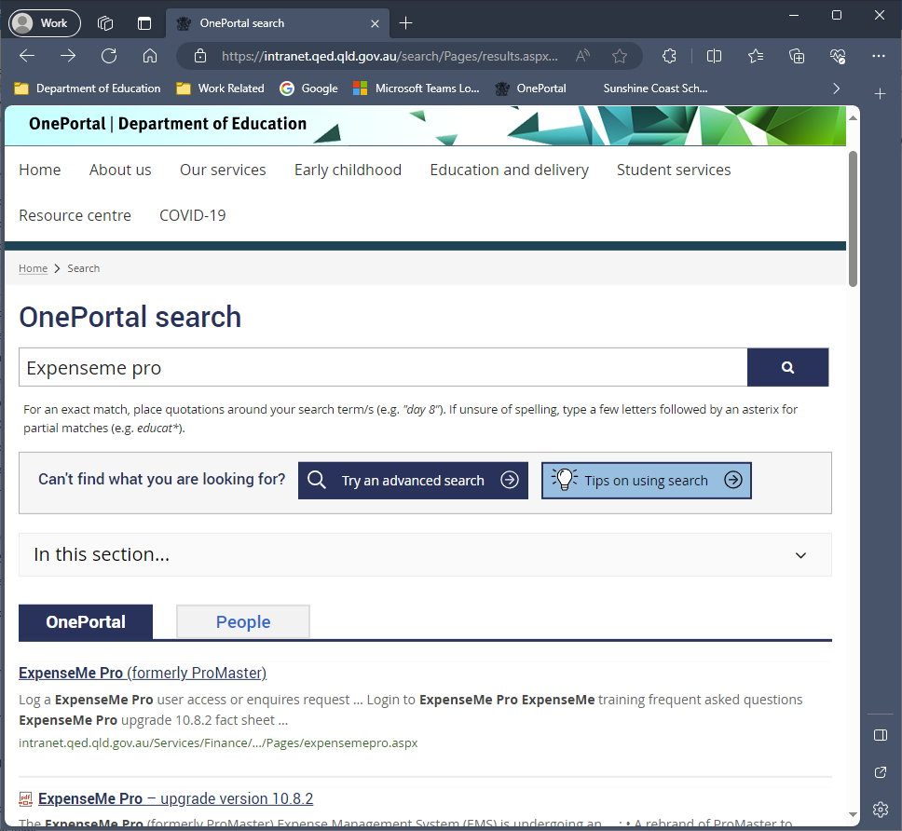

STEP 2
Click the “Login to ExpenseMe Pro” link in the ‘Related links’ section (lower right)
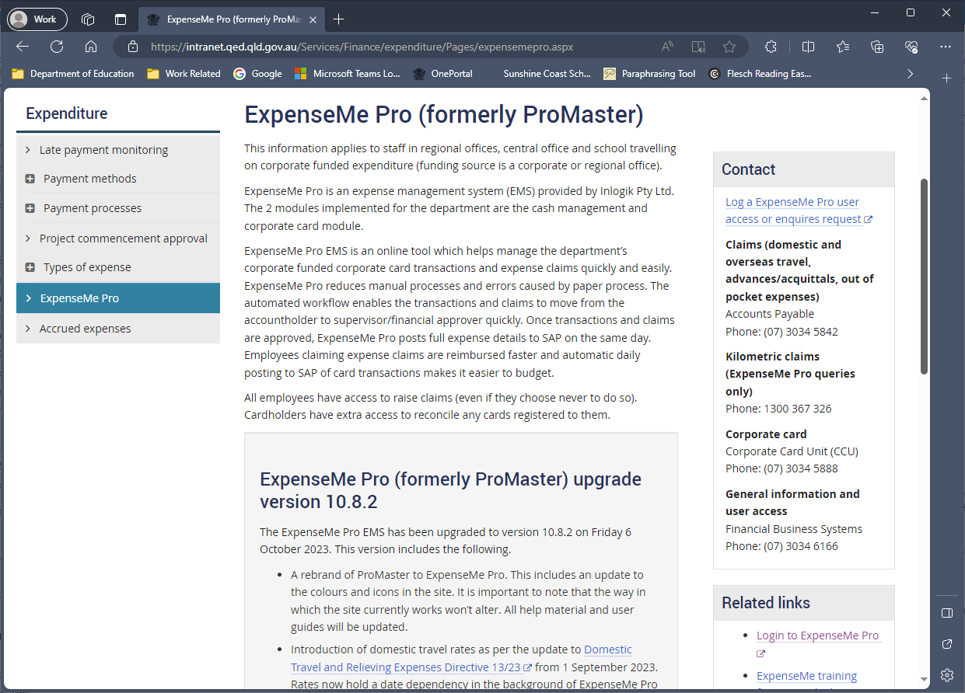

STEP 3
You need to acknowledge the legal spiel by clicking the “Continue” button
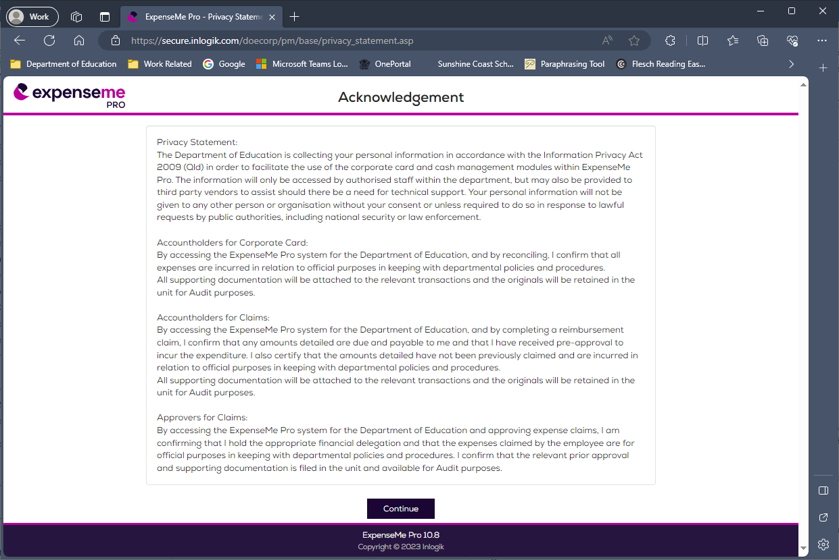

STEP 4
Welcome to your expenseme PRO Home Page. Now you will need to choose the “Create Expense Claim” action from the right-hand menu under ‘New Actions’
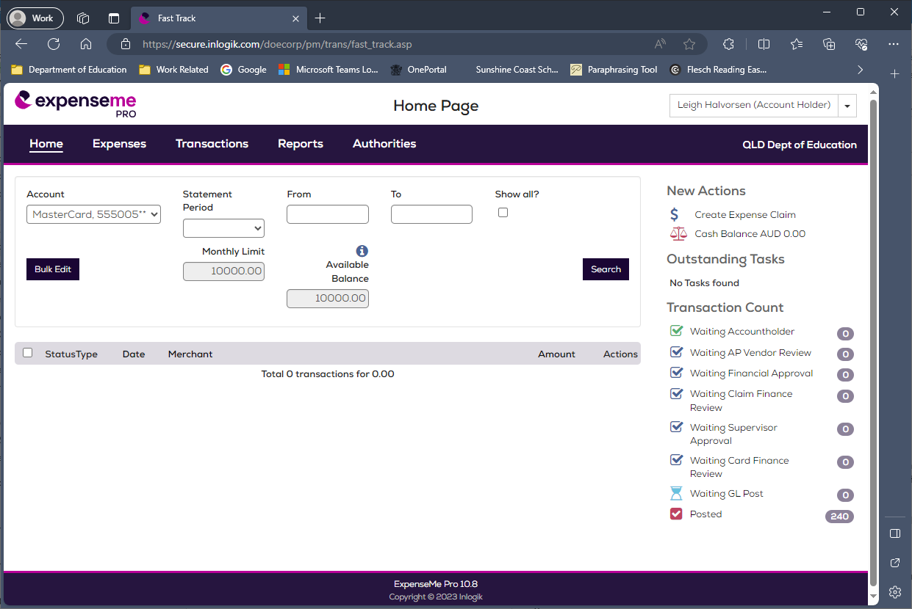

STEP 5
Type the following text into the “Purpose” field:
“Approved professional learning claim - course name” e.g. “coaching level 1 - Football”
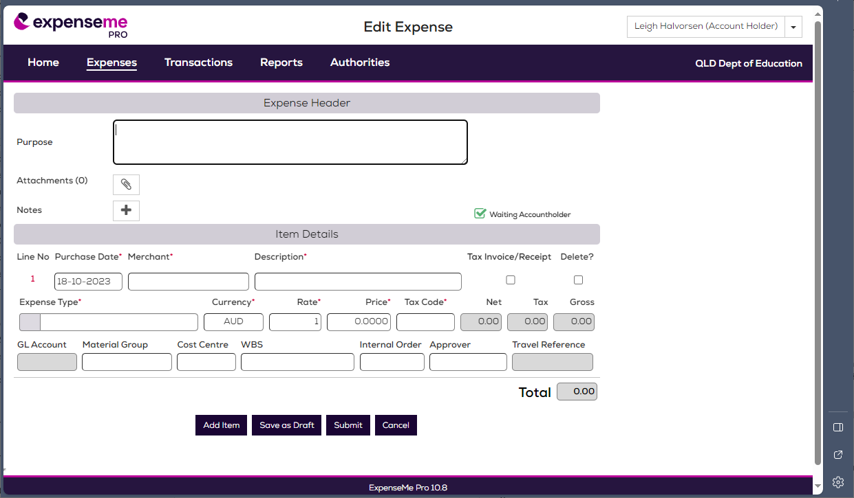

STEP 6
Pick the date that you attended the professional learning event in the ‘Purchase Date*’ field.
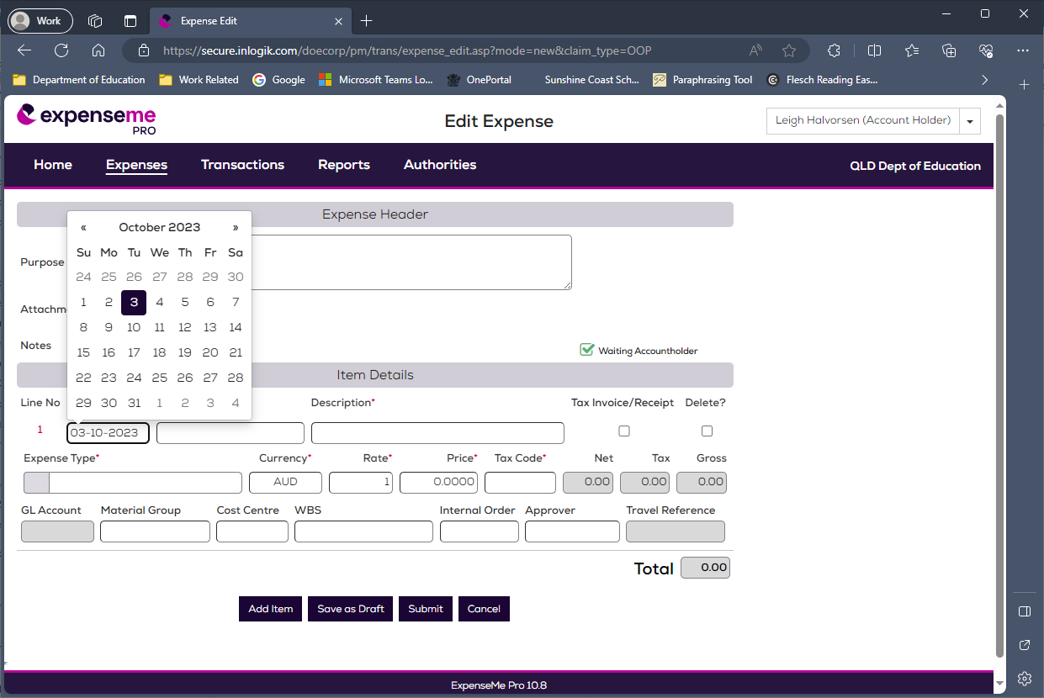

STEP 7
Type the name of the PD supplier into the “Merchant*” field. Eg “XYZ Training Co”
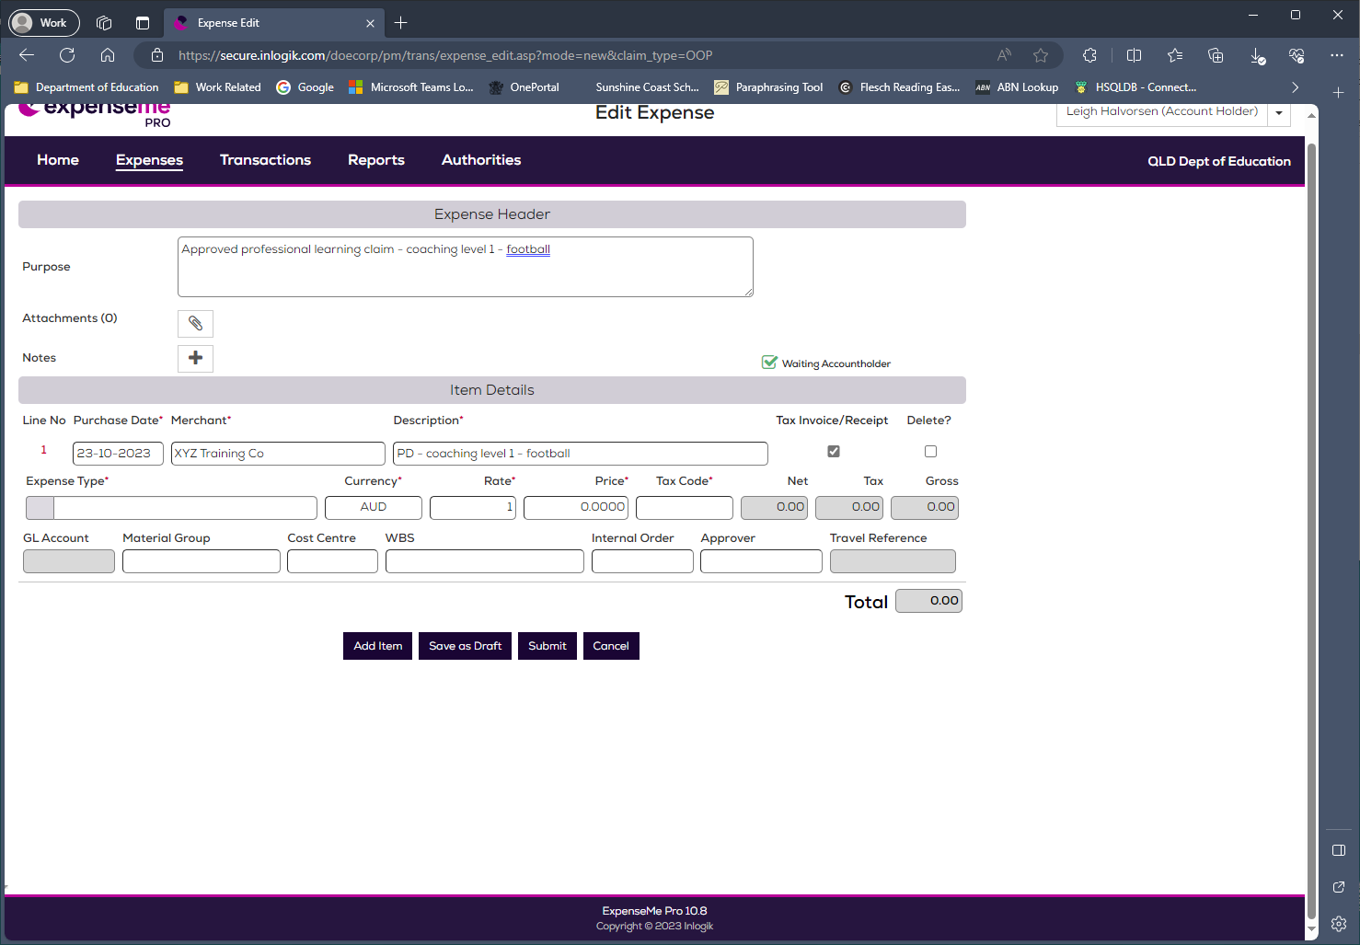

STEP8
Type the following text into the ‘Description’ field: “PD” and “pd course title” e.g “coaching level 1 - football”. Also ensure that you tick the “Tax Invoice/Receipt” checkbox.

STEP 8
Click into the “Expense Type*” field. Select ‘STAFF TRAINING’ under the ‘Staff Expenses’ item in the right panel.
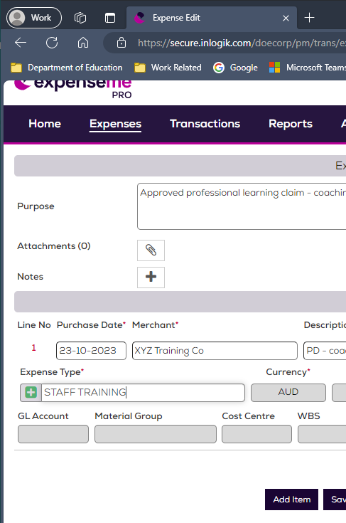
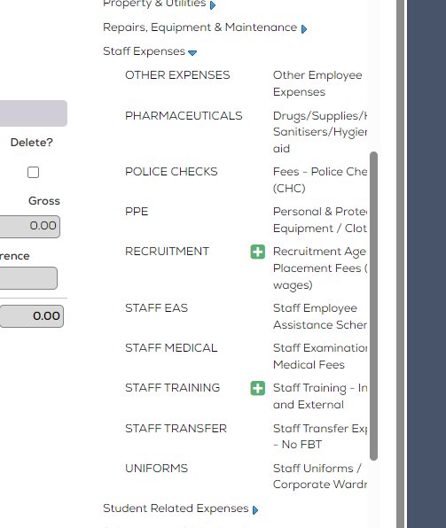

STEP 9
Key in the Training Cost. Select the Category (whether Internal Training, or External Training).
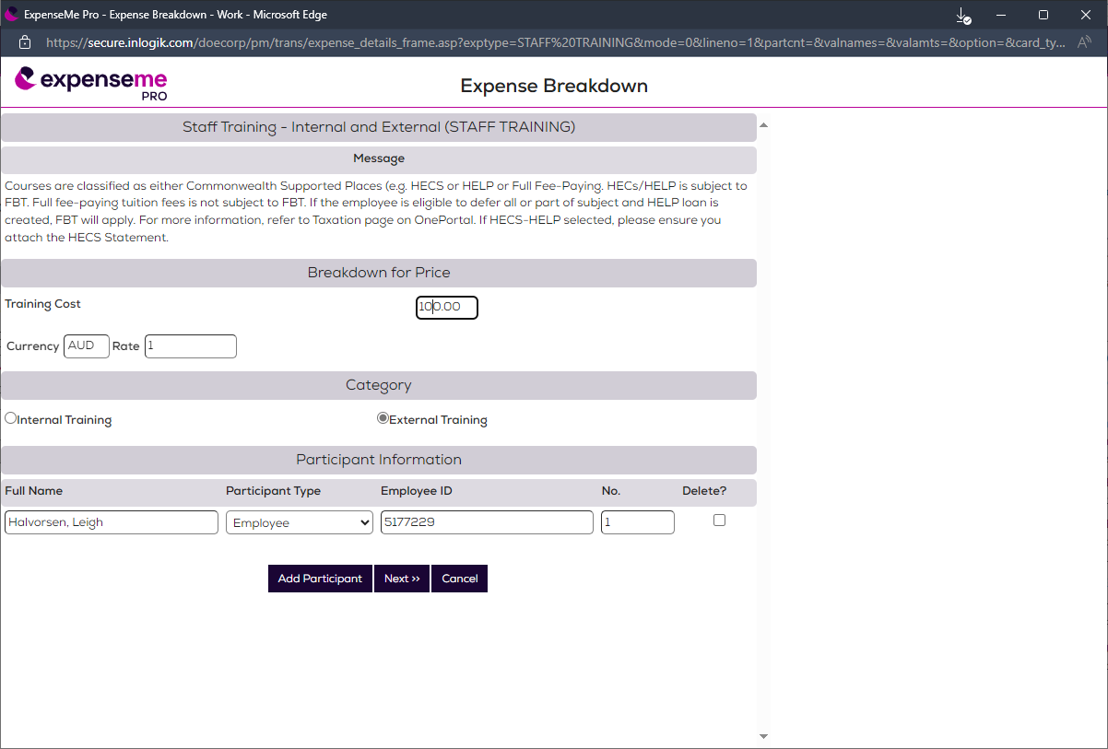
Your department of Education information will be automatically filled in for you in the “Participant Information” section of this form.

STEP 10
Click the “Next>>” button.

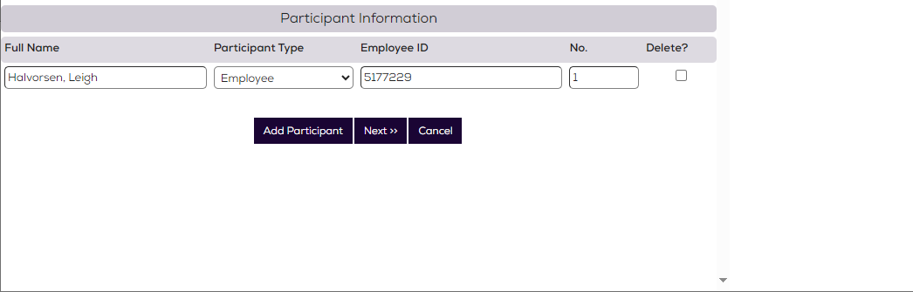

STEP 11
Check that the correct tax code is selected. This will usually be “PG” for GST paid.
Click into the “Material Group” field. Then select the appropriate PD code from the right hand menu.
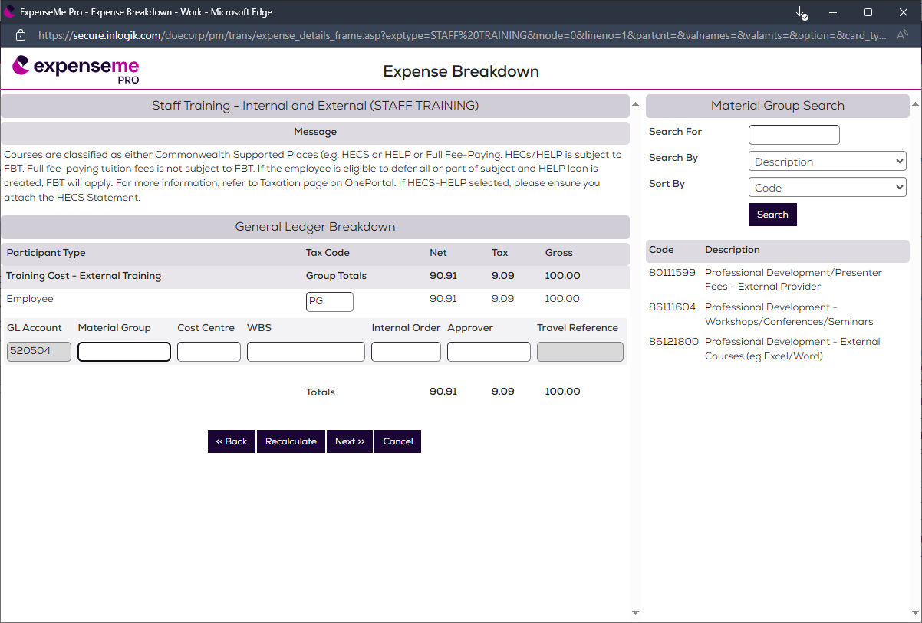

STEP 12
Click into the “Cost Centre” field and type in “2002904”
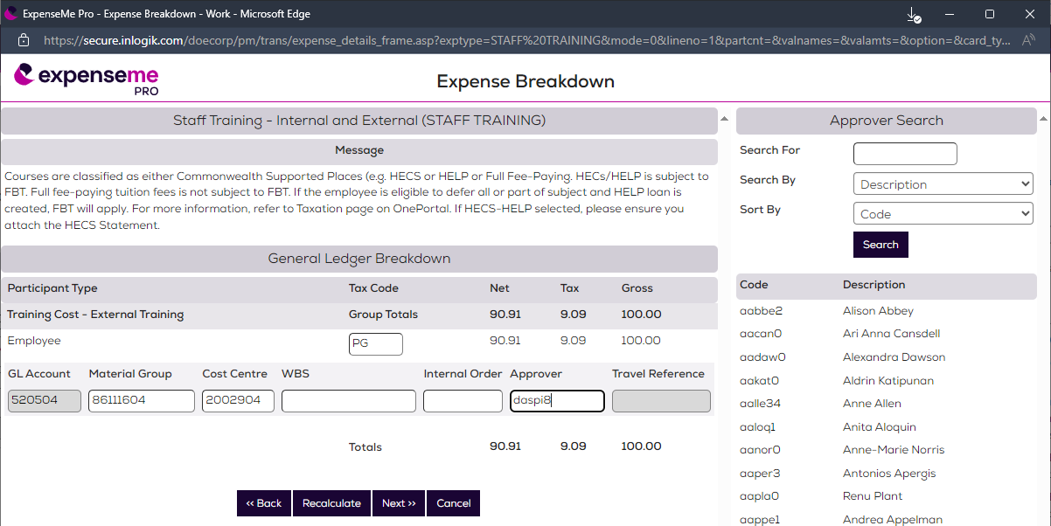

STEP 13
Click into the ‘Approver’ field. You can search for the RSSO or alternative just type “daspi8” into the ‘Approver’ field.
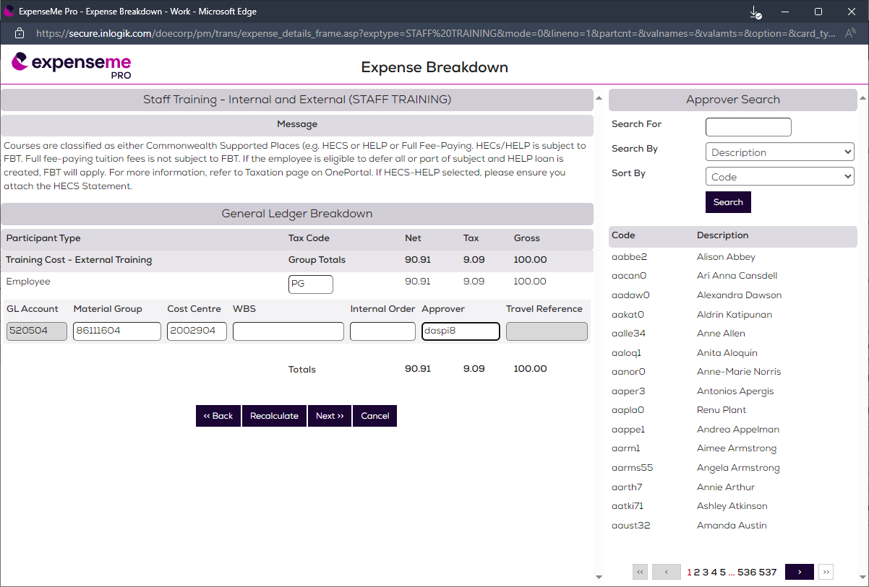

STEP 14
Click the “Next >>” button at the bottom of the ‘Expense Breakdown’ screen.
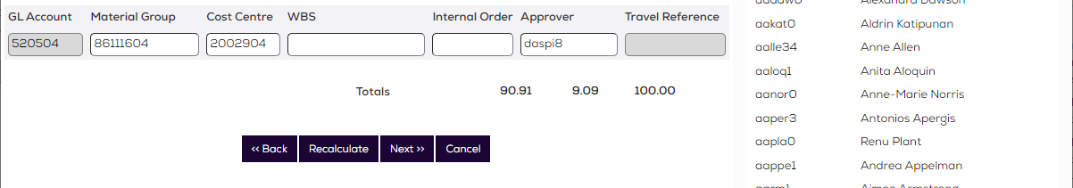

STEP 15
Now you need to answer all three questions relating to your training on this screen.
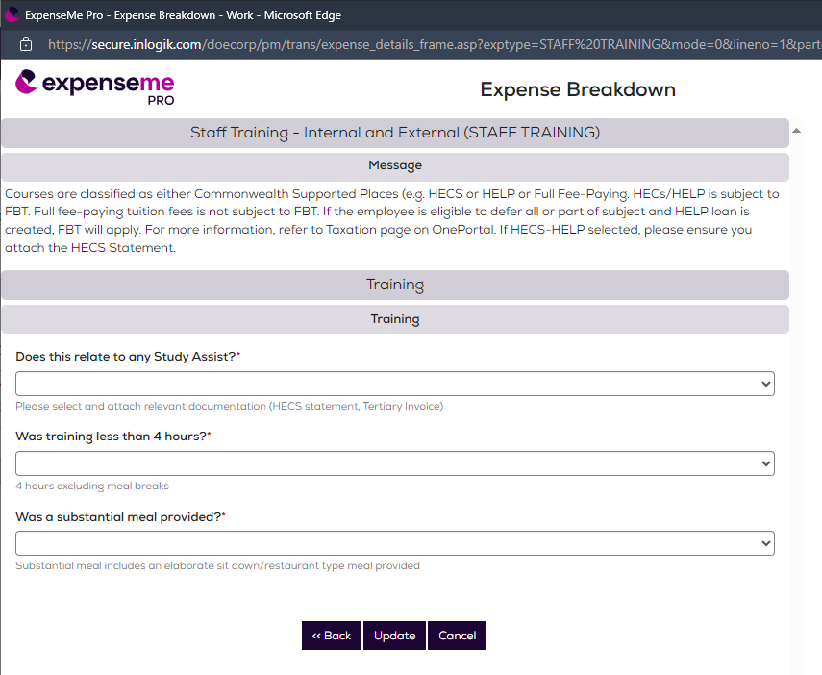

STEP 16
When you have answered these questions, click the “Update” button.
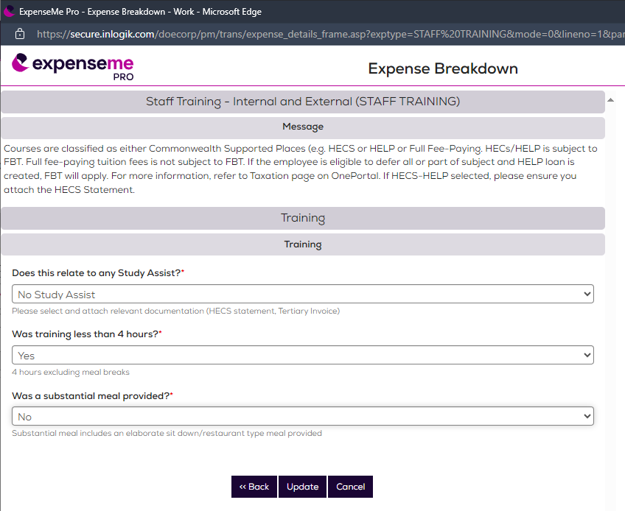

STEP 17
Your screen will return to the ‘Expense Header’ screen.
Click on the paperclip button.
Then click on the ‘Upload’ button in the right panel.
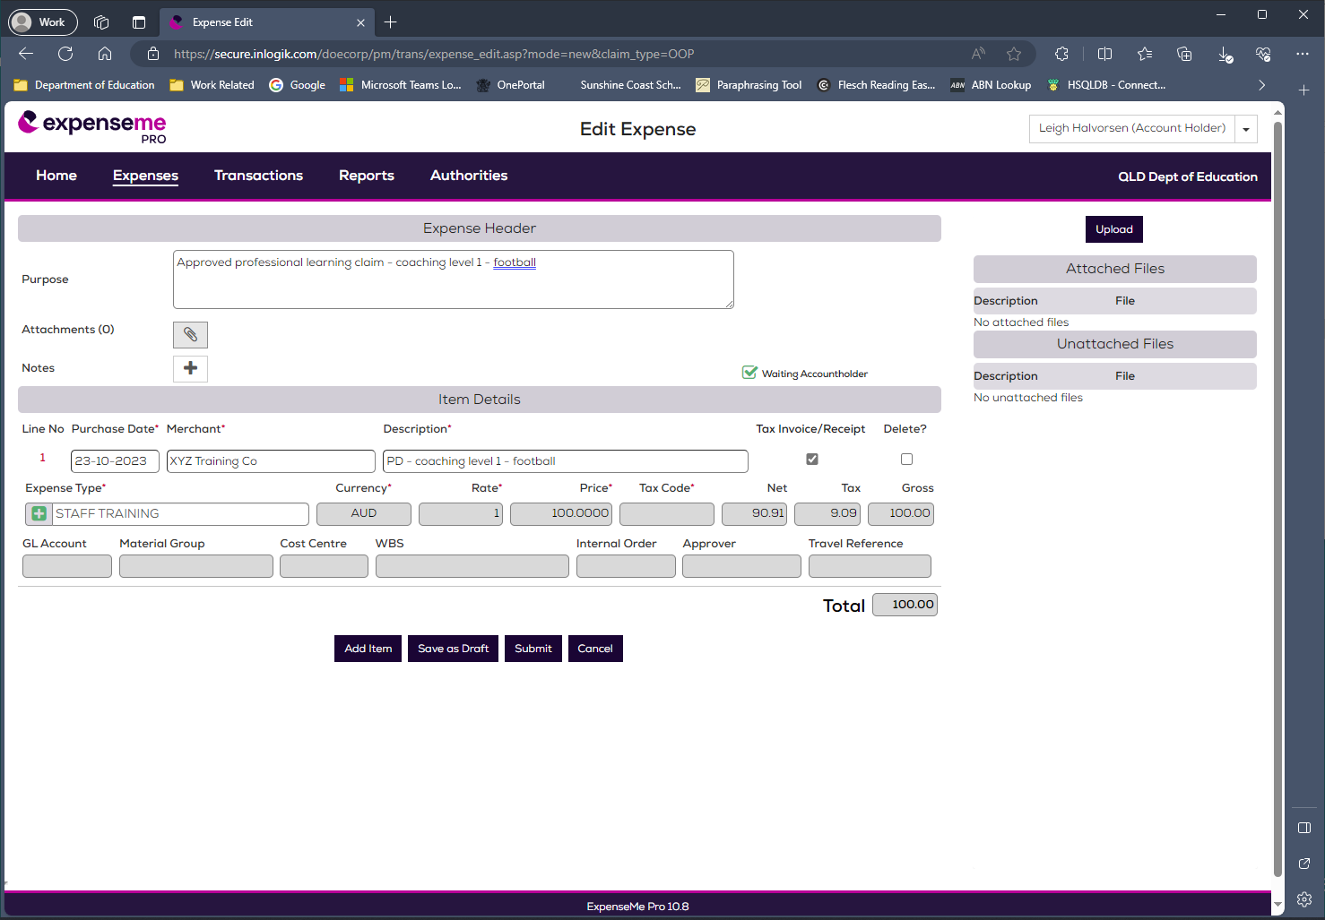

STEP 18
Click the ‘Upload button’. An expenseme PRO File Attachments screen will now appear.
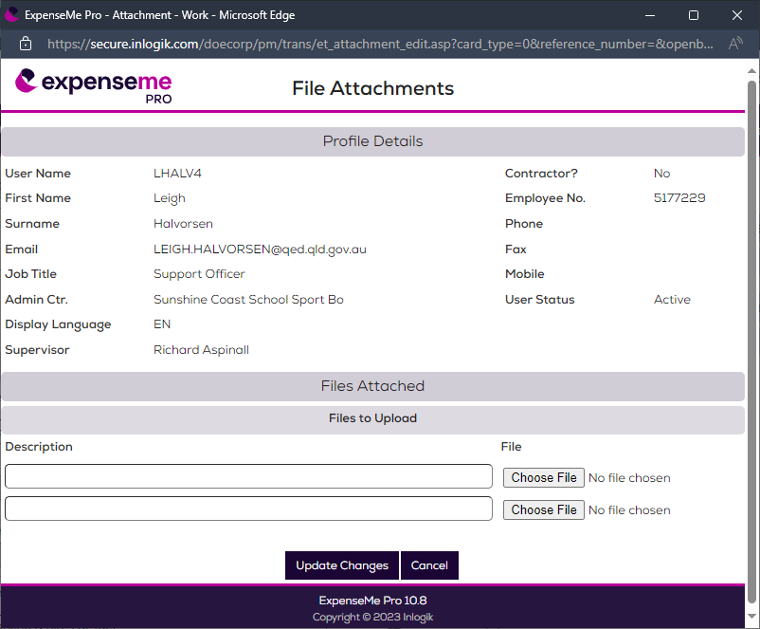

STEP 19
Click the first ‘Choose file’ button. You will then be able to upload your first PDF file (eg tax invoice) using the Open dialog box that appears.

STEP 20
An file open dialog box will now display on your computer. Use this dialog box to locate the first scanned tax invoice/receipt you wish to upload to your claim, and to attach it to your claim.
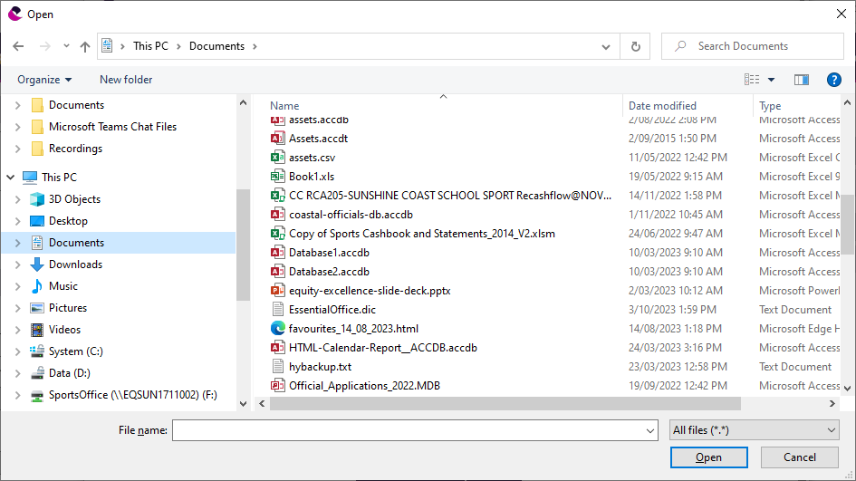

STEP 21
You will now see a list of attached files on the right under the ‘Attached Files’ area.
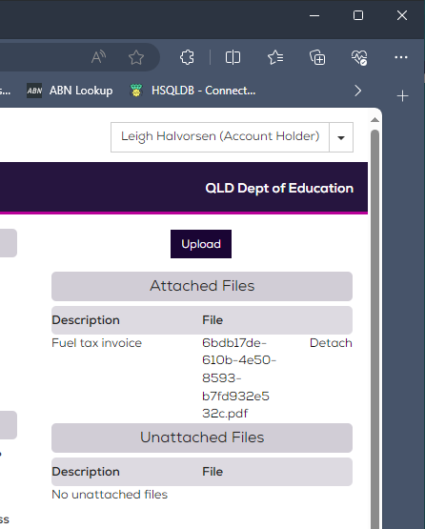

STEP 22
When you are satisfied that all the files you need to include in your travel claim have been uploaded and attached to your expenseme PRO claim, click the ‘Submit’ button and you’re done!

